**Sudo visudo**

It is used for editing /etc/sudoers file.

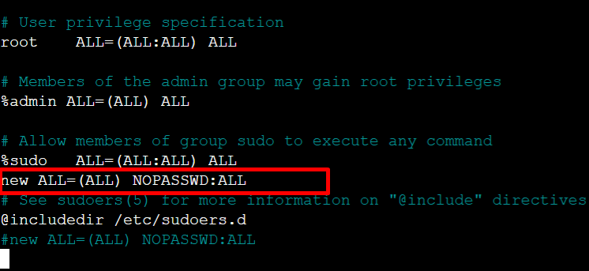

**Sudo nano /etc/passwd**

It is used for write or edit data in file.

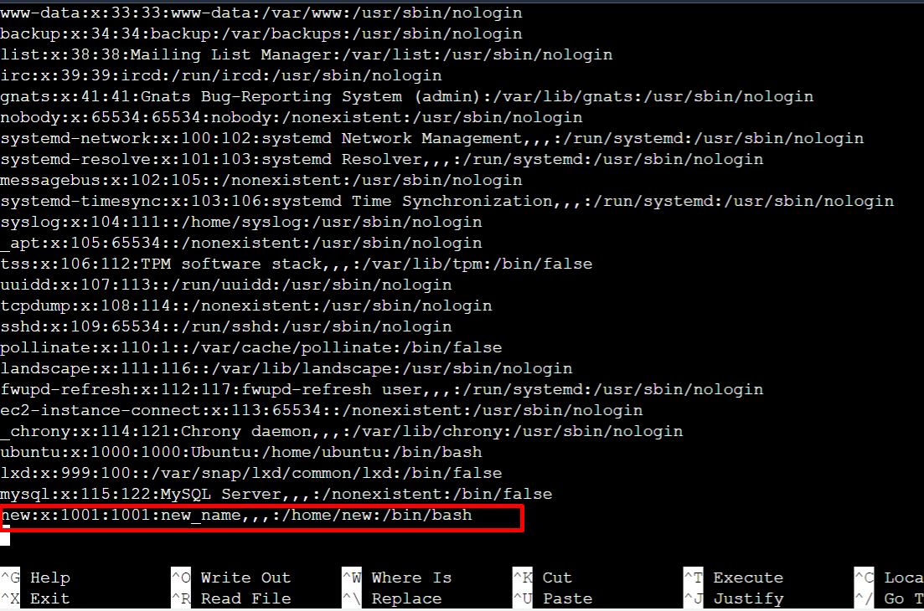

Next we login new user with **sudo su - new**

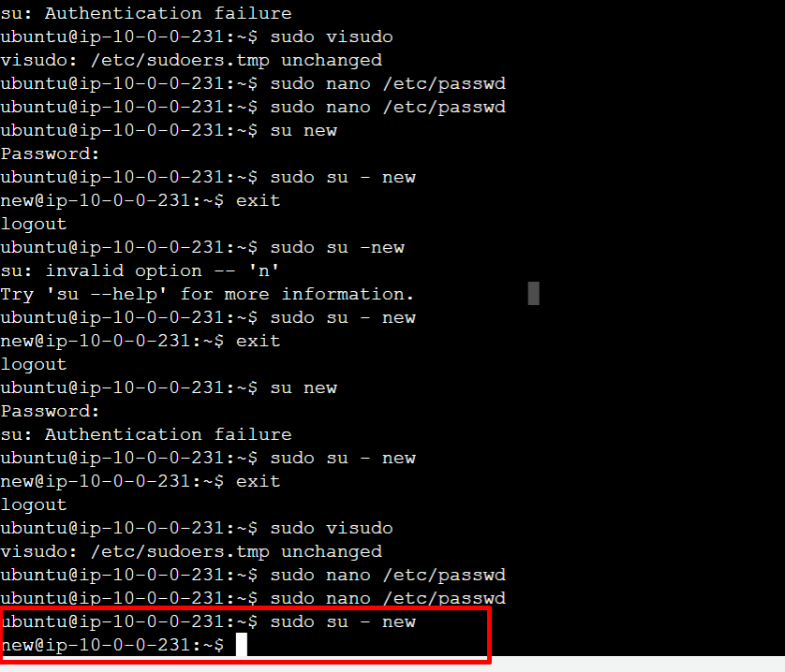

To enter **EXIT** we logout that user.

